Managerial & Investor-Level

Advantages of YUEDU Shredding Systems

(For Engineering Plastics & Recycling Industries, Including Annual ROI Energy-Saving Analysis)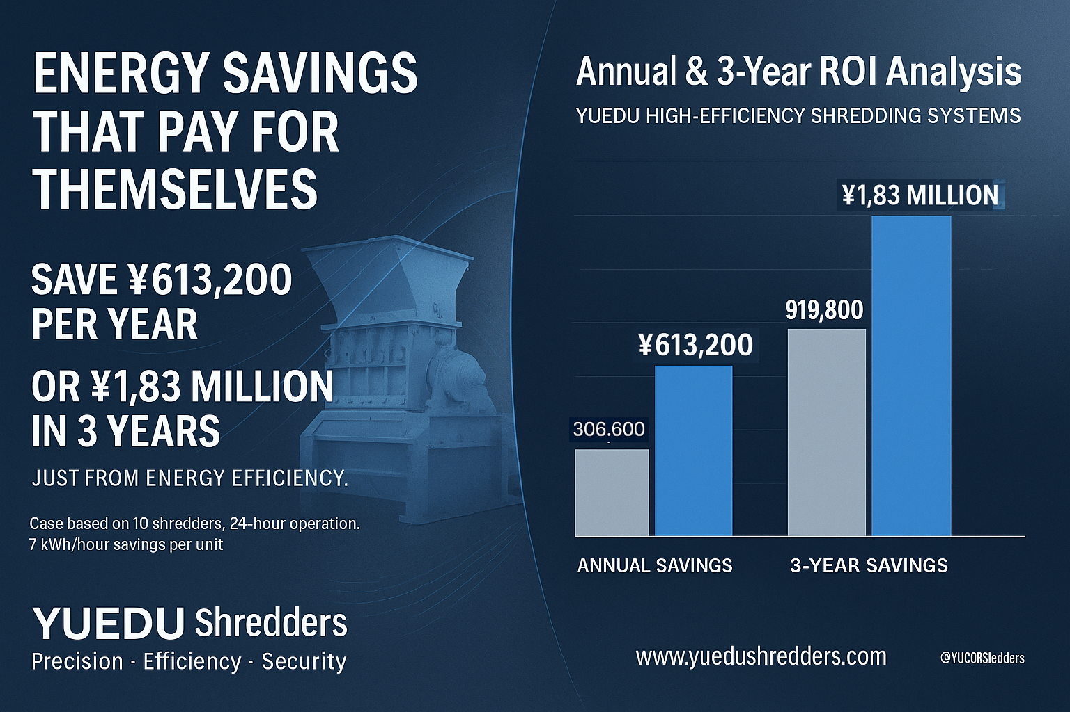
Dimension | Pain Points | YUEDU Shredders’ Core Advantage | Customer Value & ROI
① Turnkey Project – Worry-Free Management | Traditional machines require repeated coordination and on-site supervision by management. | YUEDU provides a Turnkey Solution covering research, design, manufacturing, commissioning, delivery, and training. | Management can focus on strategic goals instead of daily equipment issues — saving time and communication cost.
② EHS Compliance & Health Protection | Conventional shredders release dust, especially from glass fiber and carbon fiber, which is harmful to workers and may cause lawsuits or fines. | Fully enclosed shredding chamber with static elimination and efficient dust collection. Certified under ISO and global EHS standards. | Protects workers’ health, avoids lawsuits and penalties, and strengthens corporate reputation and compliance.
③ Energy Efficiency & Long-Term Cost Reduction | High energy consumption and heat buildup lead to significant long-term operating costs. | Optimized cutting design and high-efficiency motor reduce energy use by 20%–40%. | ⚡ Annual ROI Example (Energy-Saving ROI)  • Each machine saves 7 kWh/hour  • 10 machines → 70 kWh/hour saved  • 24 hours/day → 1,680 kWh/day saved  • 365 days/year → 613,200 kWh saved ≈ ¥613,200 per year  • 3-Year saving: 1,839,600 kWh ≈ ¥1,839,600  👉 Energy savings alone reduce annual costs by ¥1830,000, quickly recovering equipment investment.
④ Reliability & Maintenance Cost | Frequent failures and downtime cause production interruptions and dependence on limited technicians. | High-chromium wear-resistant blades, modular design, and 24-hour continuous operation capability. | Reduces downtime and maintenance dependency by over 50%.
⑤ Productivity & Efficiency ROI | Low output and slow speed increase electricity and labor costs. | 30%–60% higher throughput at the same power level; high-torque flywheel ensures efficient operation. | Saves 50% of time and power per workload, improving total line ROI.
⑥ Sustainability & ESG Alignment | Dust, noise, and poor waste management lower ISO 14001 and ESG ratings. | <68 dB low-noise design with enclosed dust extraction and closed-loop recycling system. | Enables green production, improves ESG disclosure, and enhances corporate social responsibility image.

Managerial Summary
Choosing YUEDU Shredders means choosing Peace of Mind, Power Efficiency, Cost Savings, and Risk Reduction.
It’s not just a machine — it’s a long-term ROI asset and a foundation of operational excellence.

